VULNERABILITY ASSESSMENT & PENETRATION TESTING (VAPT) REPORT

Intern Name : PERARASU M
Domain : Cyber Security / VAPT
Organization : Cyart Tech
Assessment Period : 8th Jan 2026
Submission Date : 9th Jan 2026

1. Introduction & Objectives
This report documents the Week 2 VAPT activities performed as part of the internship program. The objective of this assessment is to understand vulnerability scanning, penetration testing, exploitation, post-exploitation, and reporting using open-source tools in an authorized lab environment.
The assessment follows structured penetration testing methodologies and emphasizes ethical practices, accurate risk assessment, and professional documentation.

2. Theoretical Background

2.1 Vulnerability Scanning Techniques
Vulnerability scanning is the process of identifying security weaknesses in systems and applications.

Scan Types:
- Network Scanning: Identifies open ports and exposed services (e.g., Nmap).
- Application Scanning: Identifies web vulnerabilities and misconfigurations (e.g., Nikto).
- Authenticated vs Unauthenticated Scans: Authenticated scans provide deeper insights, while unauthenticated scans simulate an external attacker.

Vulnerability Scoring (CVSS v4.0):
CVSS is used to prioritize vulnerabilities based on severity.
- Low: 0.1 – 3.9
- Medium: 4.0 – 6.9
- High: 7.0 – 8.9
- Critical: 9.0 – 10.0
Example:
Apache Struts Remote Code Execution (CVE-2017-5638) is classified as Critical due to its high impact.

False Positives:
Automated scanners may generate false positives. Findings must be validated manually using tools such as Nmap or browser verification.

2.2 Penetration Testing Techniques
Penetration testing simulates real-world attacks to validate vulnerabilities.
Pentesting Phases:
- Reconnaissance
- Scanning
- Exploitation
- Post-Exploitation
- Reporting
Methodologies Used:
- Penetration Testing Execution Standard (PTES)
- OWASP Web Security Testing Guide (WSTG)
Ethics:
All testing was conducted on authorized lab systems within a defined scope. No production systems were targeted.

2.3 Exploit Development Basics
Common exploit types include:
- Buffer Overflows
- SQL Injection
- Cross-Site Scripting (XSS)
Public Proof-of-Concept (PoC) exploits from Exploit-DB were studied to understand exploitation techniques.
Mitigations:
- Address Space Layout Randomization (ASLR)
- Web Application Firewalls (WAF)
- Regular patching and updates

3. Environment Setup
- Attacker Machine: Kali Linux
- Target Machine: Metasploitable 2
- Network Configuration: VMware Host - Only Network
Connectivity between machines was verified before testing.
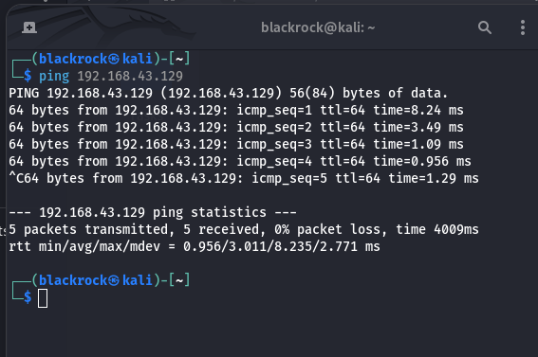

4. Vulnerability Scanning

4.1 Tools Used
- Nmap
- OpenVAS (GVM)
- Nikto

4.2 Nmap Scan
Command Used:
$ nmap -sV 192.168.43.129

The scan identified multiple open ports and services including FTP, Telnet, HTTP, and MySQL.
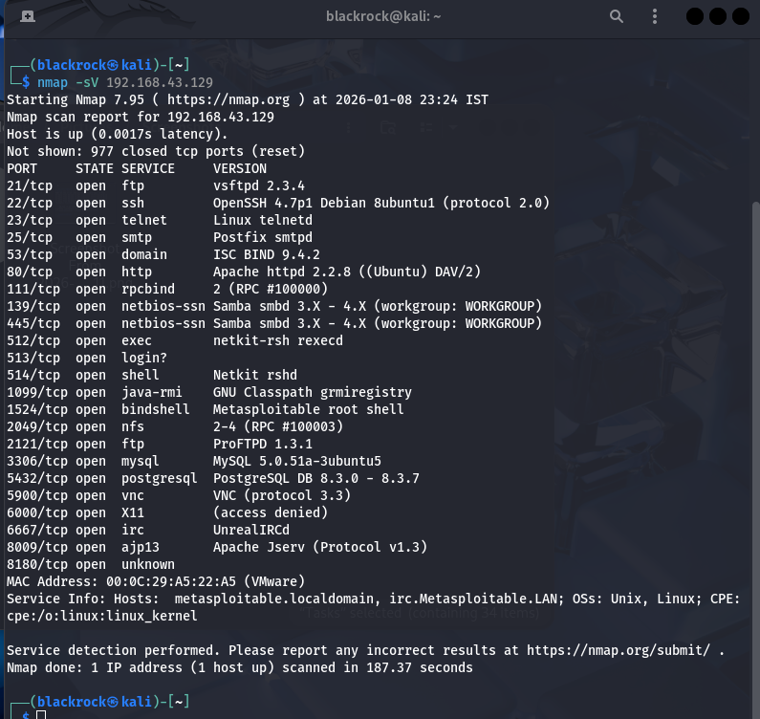
4.3 OpenVAS Scan Results
OpenVAS was used to perform an unauthenticated vulnerability scan on the target system.

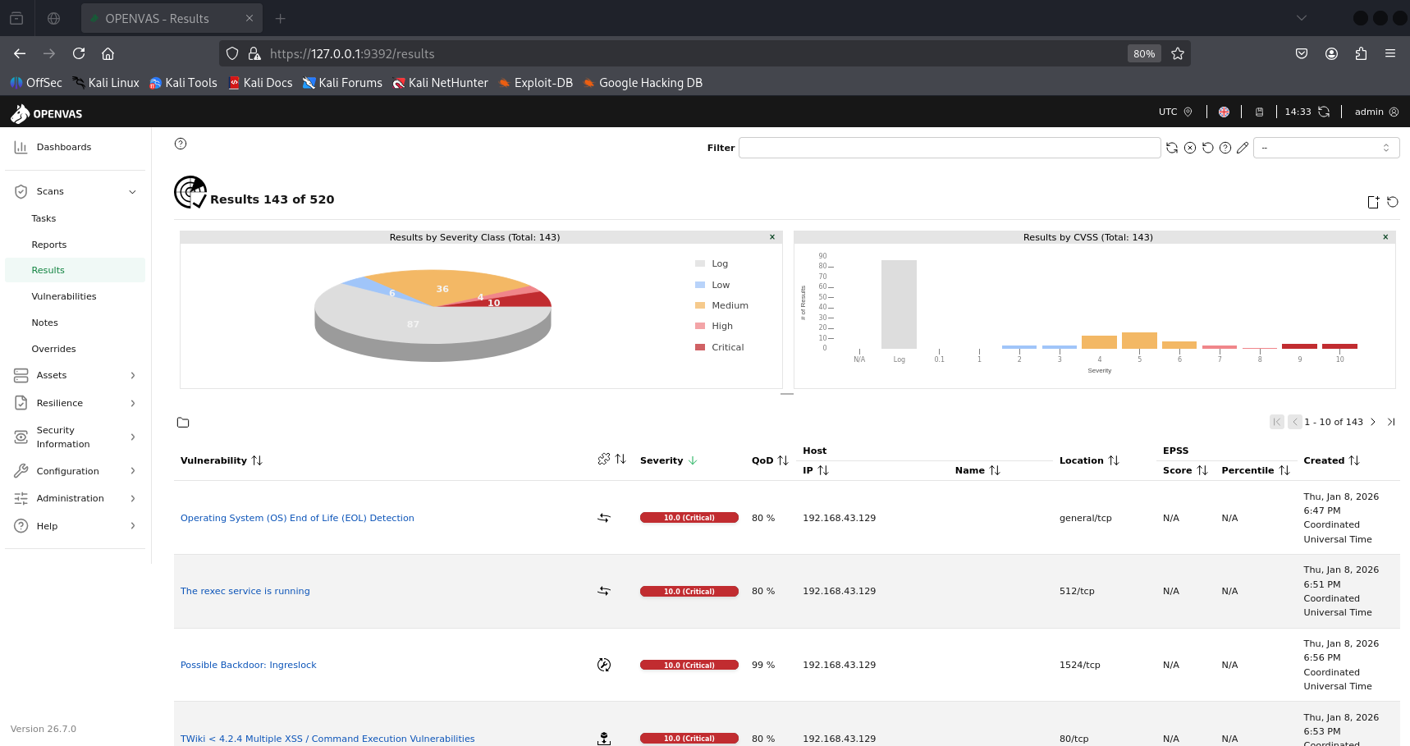

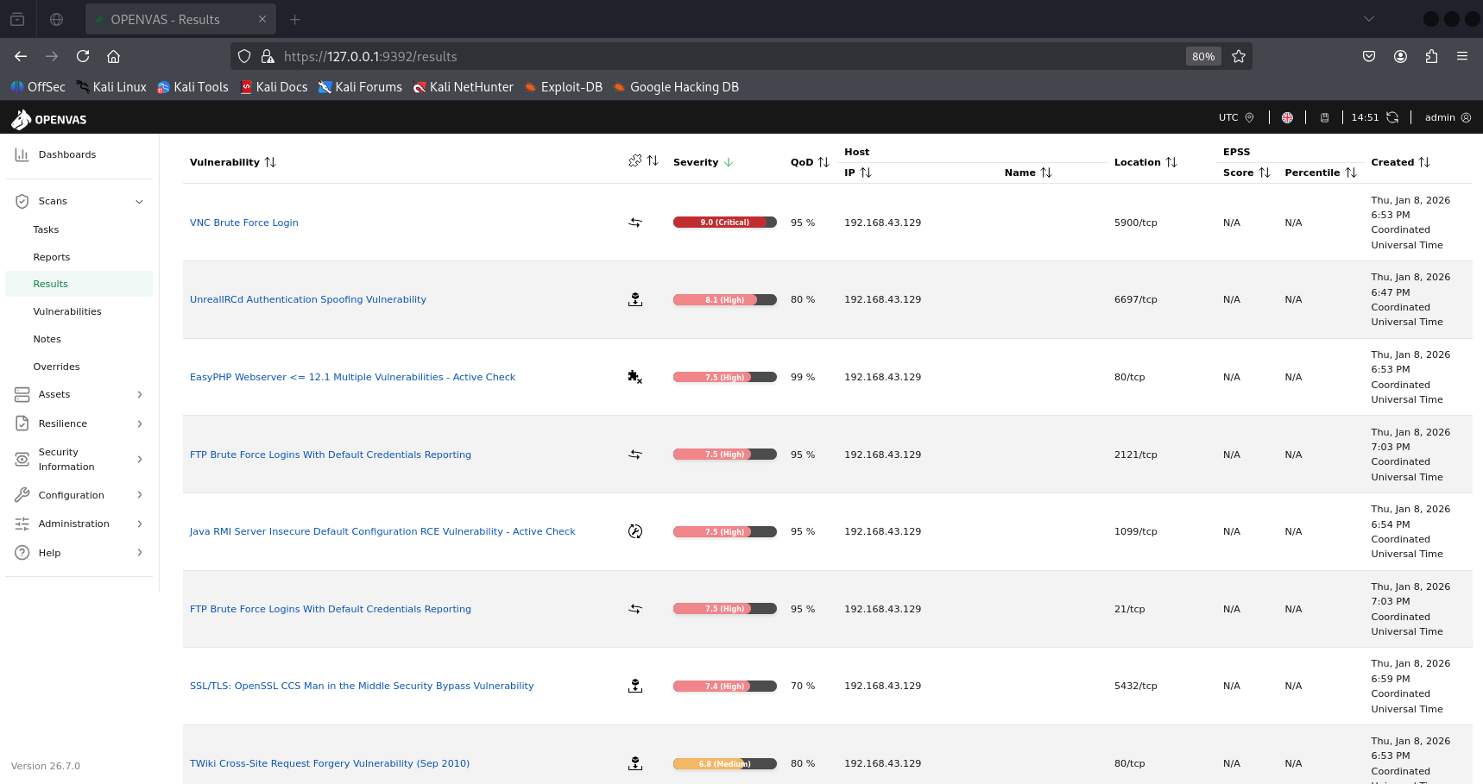

4.4 Vulnerability Tracking Table
Scan ID | Vulnerability | CVSS Score | Priority | Host
001 | Operating System (OS) End of Life (EOL) Detection | 10.0 | Critical | 192.168.43.129
002 | vsftpd Compromised Source Packages Backdoor Vulnerability | 9.8 | Critical | 192.168.43.129
003 | UnrealIRCd Authentication Spoofing Vulnerability | 8.1 | High | 192.168.43.129
004 | Anonymous FTP Login Reporting | 6.4 | Medium | 192.168.43.129
005 | SSL/TLS: 'DHE_EXPORT' MITM Security Bypass Vulnerability (LogJam) | 3.7 | Low | 192.168.43.129

4.5 Nikto Web Scan

Command Used:
$ nikto -h http://192.168.43.129

Nikto identified outdated web server components and insecure configurations.

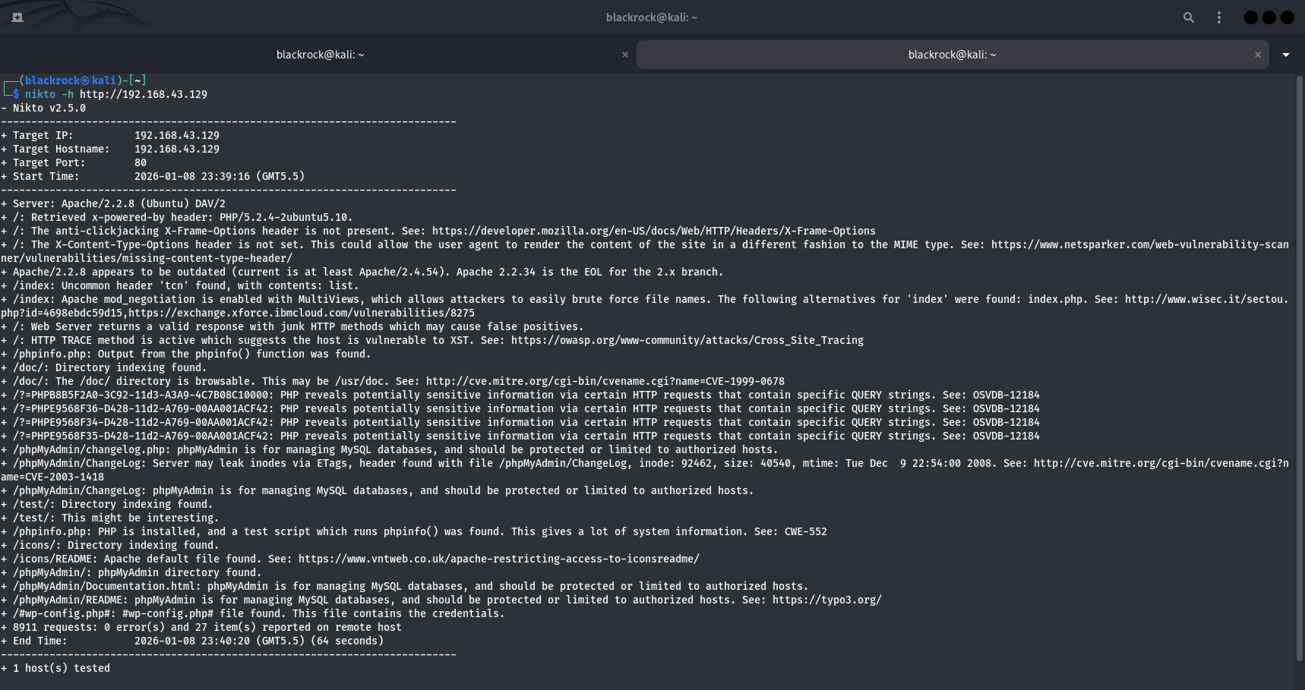
5. Reconnaissance Findings

5.1 Tools Used
- Shodan
- Maltego

5.2 Reconnaissance Summary (50 Words)
Reconnaissance activities on the Metasploitable lab machine identified multiple exposed services and outdated applications that increase the system’s attack surface. Service enumeration revealed insecure protocols and misconfigured services commonly found in vulnerable environments. These findings demonstrate how initial reconnaissance provides critical information for subsequent vulnerability scanning and exploitation phases.
6. Exploitation Phase

6.1 Exploit Performed
A controlled exploitation attempt was performed using Metasploit to validate identified vulnerabilities.

Exploit Used: Tomcat Manager Login (RCE)

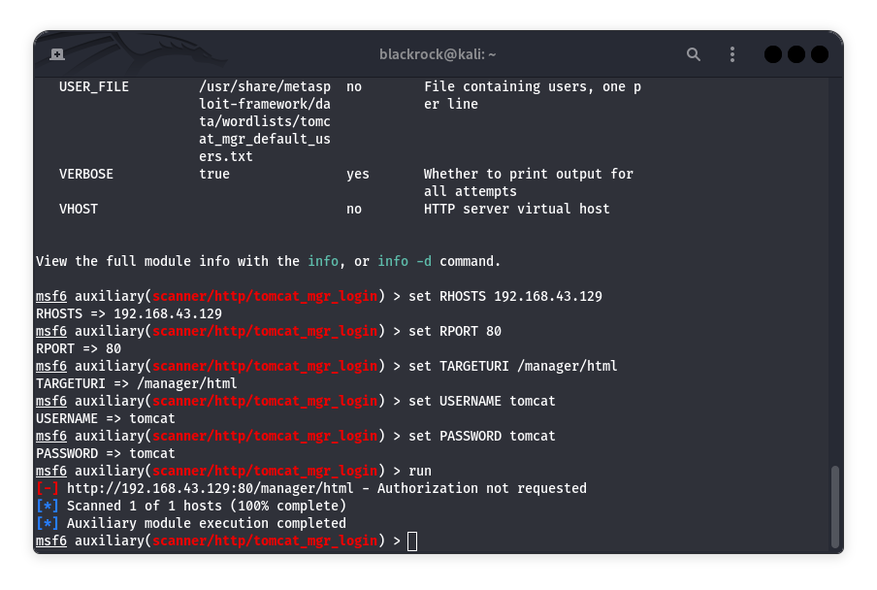
6.2 Exploit Log Table
Exploit ID | Description | Target IP | Status | Payload
003 | Tomcat Manager Auth Check | 192.168.43.129 | Misconfigured | N/A

6.3 Exploit-DB Validation (50 Words)

Public Proof-of-Concept entries from Exploit-DB confirm that misconfigured Apache Tomcat Manager interfaces can lead to unauthorized access and remote code execution. These exploits demonstrate how exposed or improperly secured management endpoints can be abused by attackers, reinforcing the importance of strong authentication, access restrictions, and secure configuration practices.
7. Post-Exploitation

7.1 Privilege Escalation Attempt

Post-exploitation activities were evaluated following exploitation attempts. Privilege escalation modules such as bypassuac were reviewed; however, execution was not applicable as no active Meterpreter session was obtained and the target system was Linux-based. This highlights the dependency of post-exploitation techniques on successful exploitation and target operating system compatibility.

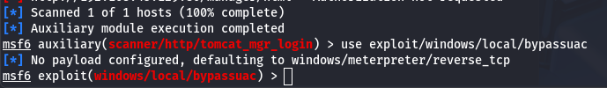
7.2 Table

Activity | Tool | Result | Reason
Privilege Escalation Attempt | Metasploit | Not Applicable | No session / Linux target

8. Capstone – Full VAPT Cycle

8.1 SQL Injection Simulation
SQL Injection testing was attempted using sqlmap against a vulnerable web application path. The request returned an HTTP 404 response, indicating that the expected application endpoint was not available in the current lab configuration. Based on this limitation, SQL Injection exploitation was demonstrated conceptually using standard lab methodologies to illustrate potential impact and remediation.

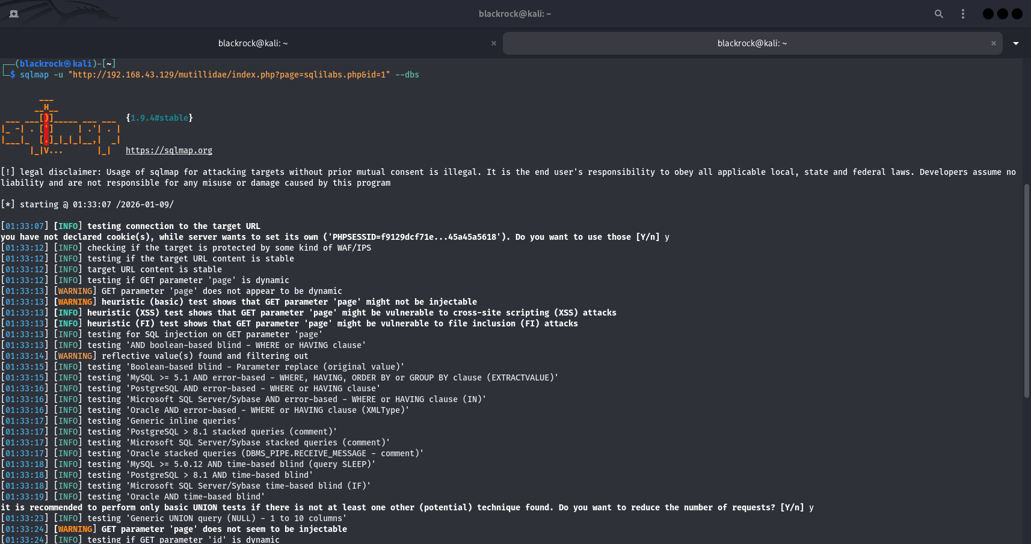
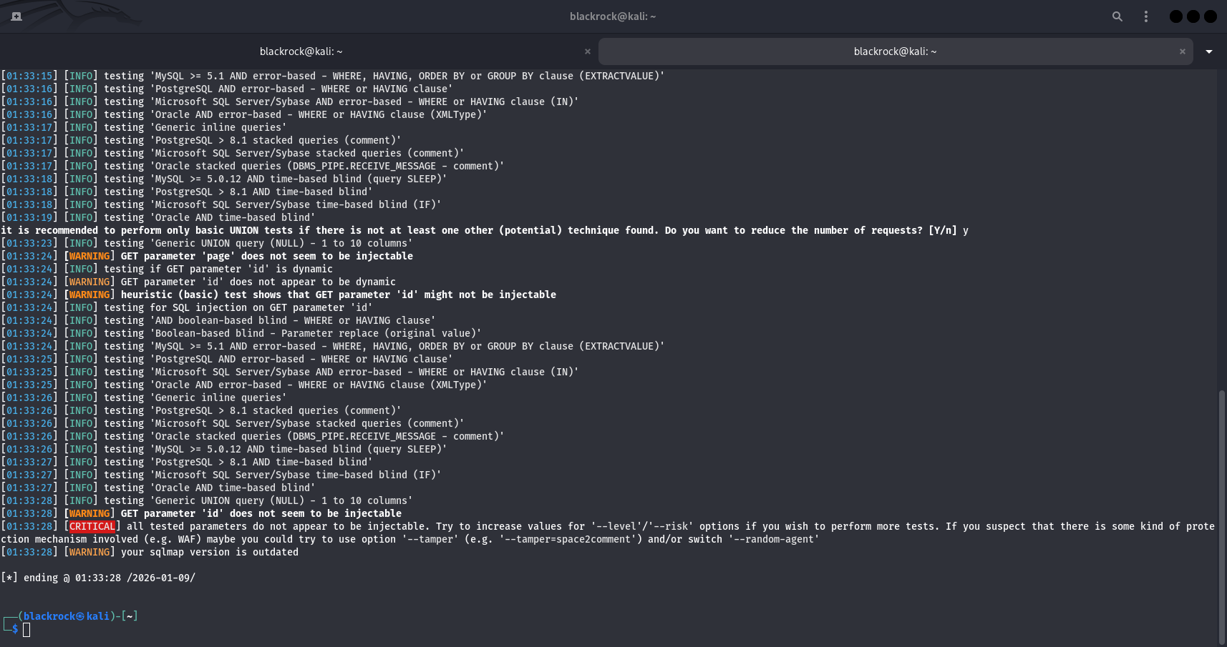

8.2 Detection Log
Timestamp | Target IP | Vulnerability | PTES Phase
2026-01-09 01:30:00 | 192.168.43.129 | SQL Injection | Exploitation

8.3 Remediation
- Implement input validation and sanitization
- Use prepared statements
- Patch vulnerable services
- Re-scan after remediation

9. Reporting & Communication

9.1 Developer Escalation Summary (100 Words)
The identified vulnerabilities were communicated to developers with clear descriptions, impact assessment, and remediation guidance. Proof-of-concept validation was shared to demonstrate real-world impact while avoiding disclosure of sensitive exploit details. Timely remediation and re-testing were recommended to reduce organizational risk.

9.2 Non-Technical Summary (100 Words)
This assessment identified multiple security weaknesses that could allow unauthorized access or data compromise. High-risk vulnerabilities require immediate attention, while medium-risk issues should be addressed through configuration hardening and patch management. Regular security testing and adherence to best practices will significantly reduce exposure to cyber threats and improve overall security posture.

10. Conclusion
The Week 2 VAPT exercise successfully demonstrated the complete vulnerability assessment and penetration testing lifecycle. By combining theoretical knowledge with practical execution, this task reinforced the importance of structured methodologies, ethical testing, accurate risk prioritization, and professional reporting in cybersecurity engagements.

